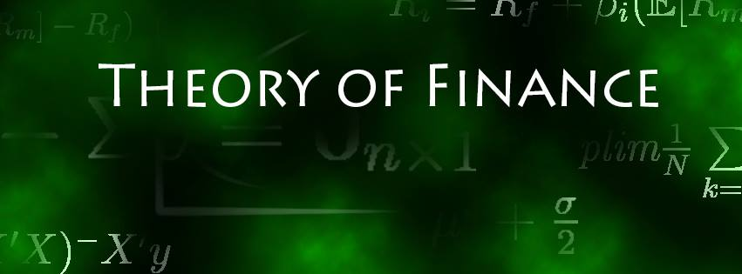

Solution Sheet on Problem Set 1

**Return Calculations, Portfolio Choice and Mean-Variance Frontier**

Deadline: 19.10.2021

**Solved by: ____________________________________________________________**

|  |  |  |
| --- | --- | --- |
| **Task** |  | **Points Earned** |
| 1. **Return Comparison**   a)  Discrete vs. Log-Returns: mean, st.dev. and annualized  (6 points) | See calculation file:  Discrete Return = discrete_return Log Return = log_return Mean of Discrete Return = discretemean Mean of Log Return = logmean Standard Deviation of Discrete Return = discreteSD Standard Deviation of Log Return = log_SD  Annualized Mean Discrete Returns = annualized_discrete_return Annualized Mean Log Returns = annualized_log_return |  |
| b)  Discrete vs. Log-Returns:  Plot and interpretation  (8 points) | Largest Maximum Difference: DB at 0.225 difference  Smallest Maximum Difference: EON at 0.0541  Chart, line chart  Description automatically generated  Chart, line chart  Description automatically generated  Given we are using log returns which have a normalizing effect on the data there is barely any difference noticeable. However, it can be clearly seen that there is an upwards curvature which is because discrete returns are always larger than the corresponding log return. |  |
| c)  Usage of return type  (6 points) | Usually the discrete return is used for calculating the return of a portfolio (i.e. multiple assets) and when choosing the different weights of assets in a portfolio.  Log returns are used when returns are aggregated across time and when comparing investment horizons for the same asset. |  |
| d)  Investment value  (6 points) | At end the of July 2021 the investment would be worth EUR 814.91 |  |
| 1. **Diversification Effect**   a)  Diversification using two stocks  (6 points) | When looking purely for diversification (regardless of any implies on return) the idea is to reduce the portfolio variance. Given the portfolio variance is defined by $$Var\left(R_{P}\right) = ω_{1}^{2}σ_{11} + ω_{2}^{2} σ_{22} + 2ω_{1} 2ω_{2} σ_{12}$$ the diversification benefit increases with decreasing correlation of the two assets. Therefore, to get the highest diversification benefit an investor should choose stocks SAP and E_ON as they have the lowest correlation out of the 10 stocks. The worst diversification benefit is achieved by only investing in a single stock (as correlation = 1). However, given two stocks need to be picked, the worst diversification effect is achieved with investing into RWE and E_ON given they have the highest correlation. |  |
| b)  Diversification and portfolio volatility  (12 points) |  |  |
| c)  Visualization and interpretation of b)  (12 points) |  |  |
| 1. **Mean-Variance Frontier**   a)  Mean-Volatility Plot  (8 points) |  |  |
| b)  Efficient Frontier  (10 points) |  |  |
| c)  Minimum Variance Portfolio  (10 points) |  |  |
| d)  Tangency Portfolio  (10 points) |  |  |
| e)  Portfolio Choice  (6 points) |  |  |